**Brooklyn torah gazette**

**For parshas shemini 5781**

Volume 5, Issue 33 (Whole Number 233) 28 Nisan 5781/ April 10, 2021

**Printed L’illuy nishmas Nechama bas R’ Noach, a”h**

For a free subscription, please forward your request to [***keren18@juno.com***](mailto:keren18@juno.com)

Past emails can be found on the website **ShabbosStories.com**

**Rabbi Zecharia Senter, zt”l**

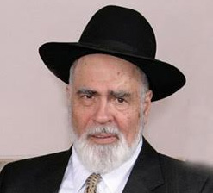

Rabbi Dr. Zecharia H. Senter zt”l, *CEO and founder of Kof-K Kosher Supervision Services, was niftar the last day of Pesach at the age of 84.*

Senter zt”l was a musmach of Yeshivas Rabbeinu Yitzchok Elchonon and a close talmid to Rav Yosef Dov Soloveitchik zt “l. He was also a Rav in North Bergen , N.J. and then in Teaneck where he lived for the past 50 years.

Rabbi Senter zt”l maintained a close relationship with many esteemed Rabbanim including Rav Moshe Aaron Poleyeff, his wife’s grandfather, Rav Ahron Soloveitchik , whom he also considered to be his Rebbe, Rav Aaron Felder, Rav Shlomo Gissinger and many others.

Rabbi Senter zt”l built the Kof-K into the internationally recognized hechsher that it is today. The Kof-K is now run by two of his sons, Rabbi Daniel and Rabbi Ari Senter.

Rabbi Senter zt”l is survived by his wife Chana, his children, grandchildren and great grandchildren – bnei Torah, involved in chessed, chinuch and harbatzas Torah in their communities and beyond.

The Levayah took place this past Monday, April 5, at RYNJ, in River Edge, NJ. The aron was then flown to Eretz Yisroel for kevurah on Har Hamenuchos in Yerushalayim.

Yehi zichro boruch.

“Rabbi Senter zt”l was a pioneer in the world of Industrial Kashrus. He was an individual of great intellect, but at the same time very warm & easy to get along with.” *–Rabbi Moshe Elefant, COO of the OU*

“Rabbi Zecharia Senter zt”l and I were actually quite close. The Senter family are tremendous Baalei Chessed. Along with his tremendous accomplishments in the kashrus industry and being the founder of the Kof-K, he was also a mathematician. Above all, Rabbi Senter zt”l was a loyal talmid of Rav Soloveitchik. He always went to the Rav’s shiurim and the Rav was very fond of him. Recently, I told Rabbi Senter’s children that I was listening to an unpublished tape of the Rav from 1961 in which he was learning Hilchos Tefillin. The Rav called on Rabbi Senter to read and said b’derech chiba, ‘Senter, you’re a mathematician. I want you to read precisely!’ ” *-Rabbi Menachem Genack, CEO of the OU*

***THIS SECTION IS PART OF AN INTERVIEW ARI HIRSCH/JEWISH VUES DID WITH RABBI SENTER ZT”L TWO YEARS AGO.***

**When and why did you get into kashrus supervision?**

I graduated from Yeshiva College in 1958. In 1959 I got my PhD in mathematics, and Smicha from RIETS in 1963. After I graduated, I taught mathematics at Fairleigh Dickinson University in the mornings, and at YU in the afternoons to supplement my income. In the early 1960s, the students at YU decided to publish a manual about kosher foods, and asked me to help them. Kashrus was always a special interest of mine. As a boy, local store owners called me “Kid Ingredients,” because I was always reading the ingredients labels on packaged foods. I knew which products were kosher, which were treif, and which were “yesh v’yesh.” So I served as the faculty advisor for the student publication, called “A Guide to Kashrut.”

**Who was your first client in kosher supervision?**

The first big company I certified was Howard Johnson Ice Cream. It was a popular product sold in restaurants that were part of the Howard Johnson motels; but it was not sold in supermarkets. I contacted the company and spoke with them about marketing kosher ice cream in supermarkets, which they eventually agreed to do. They asked me to be their certifying rabbi. It was a complicated process, because they had eight manufacturing plants across the country.

Living in New Jersey, I realized I would need to hire mashgichim to inspect the remote plants. The company agreed to pay all the necessary costs. They asked me to submit all the details on my company stationery. At the time I had no company stationery, or even a company name. So I made up a name on the spot: Kosher Supervision Service, or KSS. I had the stationery printed, and I was in business.

**Did your business grow quickly after that?**

Baruch Hashem, yes. After one year of certifying Howard Johnson Ice Cream, there was a marked rise in their sales. As a result, more business came along. The next big name in ice cream was Schrafft’s. Somebody from Scrafft’s called me and said, “We’re interested in certifying our ice cream as kosher. Do you do any other ice cream brands”? I said, “Yes, we give the certification for Howard Johnson.” So he said, “If it’s good enough for Howard Johnson, it’s good enough for us”. Later, Carvel signed on as well.

**What kinds of advice did you seek in your business?**

I went to the Skvere Rebbe to ask another question. “Should I hire one person or a Bais Din and tell them to advise me on whether or not to accept a product?” I’ll never forget his answer: “NO! Not an advisor! It has to be his singular decision, or the bais din’s group decision. You have to accept that their word is binding, final and binding”! That’s what we did. It had to be someone who tells you what to do, and it’s done! And we follow what the Bais Din says!

The KOF-K now has a Vaad Halacha, a Rabbinic Committee which is responsible for all of the Kashrus policies of the KOF-K. The Bais Din of the Vaad is comprised of three eminently qualified Morei HoRa’ah, noted Rabbinic authorities: Rav Shlomo Gissinger (zt”l). and Rav Shmuel Meir Katz, shlit’a, Rav Moshe Chaim Kahan shlit’a. The Bais Din is the final authority on all matters of kashrus at the KOF-K.

*Reprinted from the Parshat Shemini 5781 email of The JEWISH VUES.*

# Rav Avigdor Miller on Visiting

# The Amish and Yom Hashoah



**QUESTION: Would you please comment on visiting the Amish people?**

**ANSWER:** The Amish people are wise people but they’re ovdei avodah zarah and therefore it won’t help them.  A wise idol worshipper is still an idol worshipper and therefore it’s a pity on them.  However, they’re more sensible than other people in gashmiyusdikeh things but there’s no lesson there for us.  We have nothing to learn from them.  TAPE # E-120

*Reprinted from the April 1, 2021 em ail of Toras Avigdor.*

**QUESTION**: I have a question about Yom Hashoah, that’s the Holocaust day.  Where did it originate and should we observe it?

ANSWER: It originated from people who are atheists – in the Knesses most of them are atheists.  So when people like that get together, a ‘Sanhedrin of great sages’ who go bareheaded and they sit together and they decide to decree a national day of observance for all Jews, you understand already the kedushah that lies in it.

Should we observe it?  We should ignore it altogether. What *should* we do?  We’ll leave that to the chachmei haTorah. We don’t hurry to make days of observances. The chachmei haTorah will do in good time what has to be done but never should we recognize any kind of pronouncements by atheists. TAPE # 361 (May 1981)

*Reprinted from a recent email of Toras Avigdor.*

**Rabbi Berel Wein on**

**Parshat Shmini 5781**

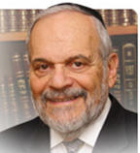

One of the more distinguishing life values which Judaism advocates is the type of food that a Jew eats. There are foods that Jews are commanded to eat such, as matzah on Pesach and continuing with Pesach, there are also forbidden foods such as leavened bread. The laws and customs regarding kosher food are numerous and complex. Perhaps no other area of Jewish life, except for the Sabbath and its laws, has evoked, over the centuries, so much scholarship and divergence of opinions regarding Halacha and practice.

**Basic Rules Regarding Kosher Food**

There are clear lines that establish the basic rules regarding kosher food. There have been many explanations and reasons given regarding this facet of Jewish life, concerning permissible and forbidden foods. These reasons range from the mysteries of kabalistic thought to the seemingly practical ideas of good health and proper diet. But, even after all the rational explanations have been expounded upon, the laws of kosher food remain one of the great commandments of the Torah for which we have no completely rational explanation.

Therefore, Kashrut belongs in the realm of Chukim -- laws and commandments that we follow simply because that is will, so to speak, of our Creator. Our limited capacity of human understanding makes for the mystery behind the commandment. But the commandment itself stands, and it is binding for whatever reason we may or may not assign to it and its performance.

**A Main Contributor to the Survial**

**Of Judaism and the Jewish People**

One thing is crystal-clear and all Jewish history attests to this commandment. The consumption of only kosher food has been one of the main contributors to the survival of Judaism and the Jewish people over the ages. It has created the necessary boundary that delineates us and our faith. By so doing, it has given us a deep realization that being a Jew relates also to the body and internal organs of a person, and not only the cerebral notion of religion that many people have.

It is very important to be a good Jew in heart and mind. But for all the unknown and unseen reasons that lie behind the survival of the Jewish people over the millennia against all odds, it is just as important, if not even more so, to be a good Jew in one’s stomach. Difficulties in maintaining proper standards in kosher food and the abandonment by many secular Jews of the entire concept of kosher food, has inevitably contributed the rates of assimilation and intermarriage of their succeeding generations. People who can eat together eventually realize they can socialize together, and the rest is obvious.

**A Great Blessing is the Abundance**

**Of All Types of Kosher Food**

One of the great blessings of our modern time is the abundance of all types of kosher food. In Israel and in the United States there is little challenge left in having to observe the commandments of kosher food. Nevertheless, a large section of the Jewish people still has not broken the bad habit of past generations, and we are faced with numerous crises of disappointments in Jewish national life. As the Torah is our friend and protector, we should always be aware of its demands. It is for our own sake that we should do so.

*Reprinted from the current website of Rabbiwein.com*

**Parshas Shemini**

**Primed for Spiritual Perfection**

**By Rabbi Bentzion Shafier**

**Founder of TheSmuz.com**

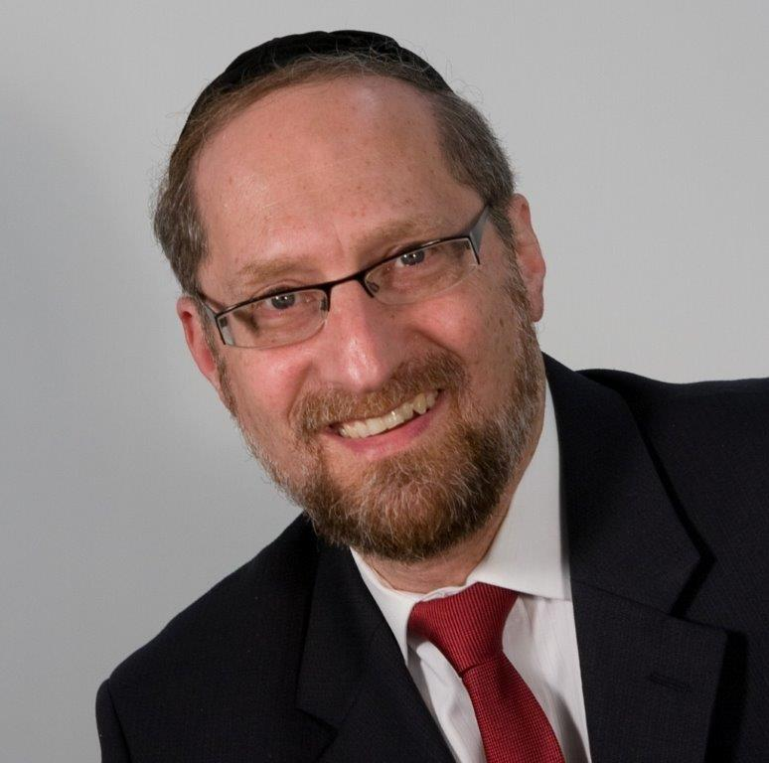

*“For I am HASHEM your G-d — you are to sanctify yourselves and you shall become holy, for I am holy; and you shall not make your souls impure through any creeping things that creeps on the earth.”* — Vayikra 11:44

The Torah seems to be connecting holiness with not eating impure food. Rabbeinu Bechaye explains that this is the Torah system for spiritual growth. By keeping the mitzvos in general and by not eating forbidden foods specifically, the desires in man become weaker and his seichel becomes stronger. Thereby, he becomes holy.

This concept is very difficult to understand. Controlling one’s desires is a fine notion, but how does that make a person sacred? It may stop him from becoming a hedonist, but it won’t make him holy.

**The Nature of Man**

The answer to this question is based on a more focused understanding of human nature.

The Chovos HaLevavos (Sha’ar Avodas Elokim 3:2) explains: When HASHEM created man, He joined two distinct elements to form his living soul. These are his spiritual soul (what we call his neshamah) and his animal soul. The conscious “I” that thinks and feels is made up of both parts.

The neshamah comes from under the throne of HASHEM’s glory. It is pure and lofty, holy and sublime. All that it wishes for is that which is good, proper, and noble. Because it comes from the upper worlds, it derives no benefit from this world and can’t relate to any of its pleasures. The other part of man’s soul is very different. It is exactly like that of an animal, with all of the passions and desires necessary to keep it alive. That is his animal soul.

**The Living Essence of an Animal**

An animal has a living essence. Just like man, it has a part that isn’t physical, but spiritual. It is attracted toward certain types of objects and repelled by others. A dog, for example, will form attachments to its master and will even risk its own life to defend him. But when the dog sleeps, its body lies there flat and almost lifeless. When it wakes up, its essence comes back again. That part of the animal, its inner essence, is its animal soul.

HASHEM implanted into the animal soul all of the drives it will need for its survival. A cat hunts mice by instinct. A bird eats worms because of an inner urge. Those instincts and hungers are part of the animal soul.

Man also has an animal soul. There is a part of him that yearns for physical things. He desires to eat, sleep, and procreate. HASHEM put into man’s animal soul all of the inclinations he needs to stay alive. If he follows these instincts, he will survive, and the species of mankind will continue.

**The Fight in Man**

These two elements of man are opposites and are competing for primacy. Each vies for control over the person. As a result, man is in constant flux. The more he uses one side, the stronger and more influential it becomes. Much like a muscle that becomes stronger with use and atrophies with disuse, if a person uses his spiritual soul to control his animal soul, it becomes stronger, and he becomes elevated. If he gives in to his desires, then the animal soul gains command. His desires become more intense and frequent. They demand to be fulfilled more often and with more force until man becomes controlled by his drives.

Life is a battle between these two forces. Ideally, if a person succeeds completely, his pure intellectual soul will harness his animal soul and use it for the purpose of keeping himself alive. However, if a person allows his animal desires to win and he follows their natural pull without controlling them, they will become stronger and eventually rule over him.

**In Fine Balance**

Most of the mitzvos of the Torah are based on maintaining a fine balance in the two sides of a human. Because these two parts of man, the neshamah and the animal soul, are at war, the Torah forbids certain activities because they give an unfair advantage to the animal soul. They strengthen it and give it extra force. Just as too much caffeine causes people to be jittery, anxious, and short-tempered, certain foods affect our spiritual balance.

When meat and milk are cooked together, the combination strengthens the animal soul of man. To understand how it does that, you would need to be a scientist of the soul. That law is called a chok because the average person isn’t schooled enough in spirituality to understand how it works. But the Torah warns us against this combination because it has the effect of making the animal soul more powerful and primary.

The Gemara (Yoma 39) tells us that treif food deadens the heart of man. When a person eats forbidden foods, it becomes more difficult for him to feel the holiness of Shabbos, to learn Torah, and to feel another person’s pain. Why is this? Because in that fine balance of his personality, the animal soul has been strengthened, and by consequence, his neshamah is weakened. The person becomes more animal-like and less G-d-like. And now, it is more difficult for him to relate to spiritual matters.

**A Pull to Holiness**

This seems to be the answer to the question on the Rabbeinu Bechaye. Within man, HASHEM implanted a neshamah so pure that it pulls him to greatness. Its only desire is to be as much like HASHEM as it can be. HASHEM is perfect. HASHEM is holy. And so, man’s neshamah pulls toward perfection, toward becoming as holy as a human can be.

The difficulty with man reaching this state is that his animal soul tugs him toward everything temporal and passing. Its desires are immediate and mundane — the opposite of all that is holy and sublime. The more that man gives in to these desires, the stronger their pull on him. If left unchecked, they would turn him into an animal in the form of a man. So the Torah warns us against these activities that will prevent us from attaining a true state of holiness.

**In Our Lives**

This concept is particularly relevant because the Torah is teaching us that being holy isn’t foreign to us. Quite the opposite, it is part of our very nature. Half of our personality only wishes for that which is elevated and proper. If we listen to that side, we will be holy. The difficulty is that there is another half of us blocking the way to that state. To grow, we have to resist its call and stand up against its pull.

Each of the mitzvos guides us toward perfection. Do this, and your neshamah will shine. Don’t do that because it will sully you and make it more difficult for you to actualize your potential.

Holiness is inborn in us. All we need to do is use the system to bring it out. When we do, we fulfill the reason for Creation and our purpose for being put into this world. We become more like HASHEM; we become holy.

*Reprinted from the website of Theshmuz.com.*

**Some Sefira Lessons**

**By Rabbi Moshe Meir Weiss**

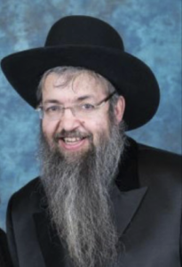

As we engage in the seasonal mitzvah of counting the sefira, and observe the national period of mourning for the tragic deaths of the 24,000 disciples of Rabbi Akiva, we should take the time to reflect upon what these experiences are supposed to teach us.

Firstly, the Gemora informs us that Rabbi Akiva’s disciples died from the horrible disease of askara, a type of lethal diphtheria or croup. The Maharsha informs us that this is a punishment for the sin of loshon hora, evil gossip. This should jolt us with the realization that even rarefied b’nei yeshiva, lofty Torah scholars, can succumb to this deadly sin if caught unaware! Thus, at this time of the year, we should be stimulated by our abstention from music etc., to pick up the Chofetz Chaim’s laws on loshon hora and become more aware of the many intricacies of the directive to guard our tongues!

**All Too Possible to Engage in Ugly Sin**

Without the proper perusal of these laws, it is all too possible that we might engage in this ugly sin, chas v’shalom, without realizing our transgressions. Take for example the Chofetz Chaim’s comments in Klal Yud #12 where he informs us that if someone fails to do you a favor, which is not something terribly bad, and you reveal this to others, it is absolutely considered loshon hora! In the same vein, if you went to a town and you weren’t greeted warmly, and subsequently relate this to your townspeople, you are guilty of defaming a whole town. (This mandates we must be very concerned about making offhand remarks like, “The people in that Shul aren’t friendly.”)

In Klal 9 #5, the Chofetz Chaim charges us not to hesitate to berate our young children if we hear them talking badly about people. He elaborates that the neglect of this sort of chinuch is a primary reason for the proliferation of this sin in adults. Obviously, if children grow up saying whatever they want even upon maturity, when they later on realize they are engaging in the heinous crime of loshon hora, it is a very hard custom for them to change. It is therefore incumbent upon us as parents to cultivate in our children a natural inhibition to speak badly about others, just like we condition them from a very young age to watch that they don’t put forbidden food into their mouths!

**Making a Statement on a National Level**

Regarding to the mitzvah of sefiras ha’omer, the Chinuch explains that we are making a statement, on a national level, that the one commodity Jews counts towards, as one counts excitedly to a vacation or wedding day, is the day of Mattan Torah (Shavuos). This is our public declaration that our number one national treasure and identity is the Torah! However, as in all areas, Hashem doesn’t want mere lip service from us. Thus, the true spirit of sefira is to examine our daily schedules and see if we give enough time to our Torah studies.

The Gemora informs us, “Tchilas dino shel adam eino ela b’divrei Torah — Man’s final judgment will begin with none other than a grilling about his time spent on Torah study.” In Masechtas Shabbos [31a], the Gemora elaborates that we will be asked by the heavenly tribunal, “K’vata ittim laTorah — Did you fix times for Torah study?!” The Shulchan Oruch (Orach Chaim 155:1) defines this responsibility as putting aside a specific time of the day for learning and to ensure that you will not violate this set time even if it means losing substantial profit. The Mishna Berurah (ibid #4) adds if one must miss his appointed time, he should ‘pay it back’ by learning double the next day!

**One Should Have a Fixed Period to Study Torah**

The Biur Halacha (ibid) informs us that in Yoreh Daiah (246:1), we are further instructed that one should have a fixed period during both the daytime and nighttime. He suggests therefore having a study period right after the morning prayers and again in the gap between mincha and maariv. Of course this prescription will not fit for everyone, as some people must rush out immediately after shacharis to catch a bus. Perhaps they might make their set time before shacharis, while other people who daven maariv right after mincha might establish their nightly schedule right after maariv.

Whatever our lifestyle, we should carve out two fixed times for Torah study from our daily life, even if it’s initially only five minutes each, so that we can be certain to be able to answer the question that will determine our eternal fate (after 120 years of good life) with a resounding affirmative!

**One with Limmited Time Should**

**Focus on Learning Practical Halochos**

The Mishna Berurah offers us the following guidance as to what we should learn. He explains that one who only has a limited amount of time for Torah study should learn practical halochos in order to know how to live like a proper Jew. Additionally, we are guaranteed that one who studies halochos every day (ibid. Shaarei Teshuvah, who states a minimum of two) can be assured of a place in the Afterlife!

One should also include in his budgeted time a review of the weekly Torah portion. This not only promotes one’s emuna, as assured by the Chofetz Chaim in his letters, but also increase one’s longevity, as stated in the Gemora in Masechtos Brachos. An inclusion of a learning seder in Mishnayos is helpful in protecting one from the fires of Gehennom (stated in the preface to Medrash Talpios).

Finally, one should include a regimen of Mussar study (Torah ethics and lessons of self-analysis and improvement). First, this will assist us in acquiring the fear of Heaven which is our primary purpose in life. Secondly, as the Baalai Mussar tell us, by including Mussar in our learning, we will make sure that we will find even more time to learn!

**Ask Your Wife for Her Input**

When planning this most important of scheduling, I recommend strongly that one should sit down with one’s wife and have her input in the chosen times. This will give her a great cheilik (portion) in the mitzvah and will insure that you don’t fix a time that you’ll have to habitually break (e.g. before candle lighting on Shabbos or carpool time).

Finally, the Mishna Berurah cautions that we should not consider our “fixed” times as the only times we have available to study Torah. A Jew must study Torah at all available times! Rather, these fixed times are the ones that are sacred and not to be trespassed upon except in cases of extreme urgency.

In the merit of having a regular daily diet of Torah study may we all merit the blessing of, “Orech yomim b’yamina b’smola osher v’kavod — Long life to the Torah’s right and wealth and honor to Her left!!”

*Reprinted from the Parshat Shemini 5781 email of The JEWISH VUES.*